Task -1
Defects
Defect # | Location | Defect type | Classification | Description | Status | Date corrected
1 | 2.2  Product Position statement  [Electronic tool rental]  Page 1 | Ambiguity | Minor | The description is ambiguous regarding whether the system is mobile app based or web based or both
2 | 2.2  Product Position statement  [unlike the existing solution]  Page 1 | Inadequacy | Major | The description of the existing solution could have been made more concise, by also adding the cost of rental factor to it, as cost is a major differentiator.
3 | 3.1 Stakeholder Summary  Page 2 | Omission | Major | Did not mention a major stakeholder which is directly connected with the system which is finance and accounting employees that takes care of the flow of money and payments.
4 | 3.4  Key Stakeholder or User needs  [4. Security]  Page 3 | Opacity | Minor | The proposed solution did not clearly clarify how security will be ensured and what measures will be taken.
5 | 4.1  Product  Perspective  Diagram 4.1.1  Context Diagram  Page 4 | Unintelligibility / Ambiguity | Minor | The diagram mentions a relation of payment between ETR and customer, but fails to justify how it is going to be carried out.
6 | 4.1  Product  Perspective  Diagram 4.1.2  Possible Interfaces [External and Internal]  Page 4 | Noise | Major | Figure 4.1.2 does not have a very important interface which is Payment system
7 | 6.4  Performance Requirements  Page 6 | Omission | Minor | Performance requirements does not mention an important aspect which is Availability, which states as to when and for how long the system will be available.

Inconsistencies

# | Location | Inconsistency type | Classification | Description | Status | Date corrected
1 | 2 – 2.1  Problem statement  S1:  S2: | Terminology clash | Weak | Here, the word highlighted in bold, that is Improvement and Refinement actually means the same. But words with similar meaning are used at different places.
  Lack of availability of tools and gadgets for improvement purposes and the cost associated with purchasing them.
  The common people are unable to get access to the equipment they need for their refinement at reasonable prices.
2 | 3 – 3.1[System Administrator]  S3  S4 | Structure Clash | Weak | Here, manages and monitors the technical functionalities and handles the technical part of the system, resolves to the same idea but the structure of the writing varies.
  Manages and monitors all the technical functionalities of the system that makes the service run efficiently.
  Handles the technical part of the system like the maintaining the website and frequently updating it
3 | 3 - 3.2 [User summary]  S5  S6 | Terminology  clash | Weak | Here, lease and renting the equipment essentially accounts the same, but two different terminologies are used for the same thing.
  Primary end user of the system who would lease the equipment
  Viewing and renting different tools and making the payment for renting the equipment
4 | 5 – 5.5,5.6,5.7,5.10 [Product features]  S7  S8 | Designation clash | Weak | Here, users and customers are same. Users and customers ae used in multiple statements but they are essentially same.
  The users can check and update their personal information at their will by navigating to the profile page.
  The customers will be able to see the specifications of the equipment they wish to rent.
5 | 5 – 5.9  Heading [S9]  S9  S10 | Designation clash | Strong | Here, the product feature is about branch employee dashboard and the description mentions dashboard for branch manager. This can arise a strong conflict
  Branch employee dashboard
  A separate dashboard will be there for branch managers through which they will be able to add and remove tools and equipment from the website.

Task 2
Interaction Matrix

Statement | S1 | S2 | S3 | S4 | S5 | S6 | S7 | S8 | S9 | S10 | Total
S1 | 0 | 1000 | 0 | 0 | 0 | 0 | 0 | 0 | 0 | 0 | 1000
S2 | 1000 | 0 | 0 | 0 | 1000 | 1000 | 0 | 1000 | 0 | 0 | 4000
S3 | 0 | 0 | 0 | 1000 | 0 | 0 | 0 | 0 | 0 | 1 | 1001
S4 | 0 | 0 | 1000 | 0 | 0 | 0 | 0 | 0 | 0 | 1 | 1001
S5 | 0 | 1000 | 0 | 0 | 0 | 1000 | 0 | 0 | 0 | 0 | 2000
S6 | 0 | 1000 | 0 | 0 | 1000 | 0 | 0 | 1000 | 0 | 0 | 3000
S7 | 0 | 0 | 0 | 0 | 0 | 0 | 0 | 0 | 0 | 0 | 0
S8 | 0 | 1000 | 0 | 0 | 0 | 1000 | 0 | 0 | 0 | 0 | 2000
S9 | 0 | 0 | 0 | 0 | 0 | 0 | 0 | 0 | 0 | 1 | 1
S10 | 0 | 0 | 1 | 1 | 0 | 0 | 0 | 0 | 1 | 0 | 3
Total | 1000 | 4000 | 1001 | 1001 | 2000 | 3000 | 0 | 2000 | 1 | 3 | 14006

Task 3
Conflict Resolution
S3:- Manages and monitors all the technical functionalities of the system that makes the service run efficiently.
S10:- A separate dashboard will be there for branch managers through which they will be able to add and remove tools and equipment from the website.
This conflict can be resolved by specializing the conflict source or target. Identifying that S3 is the role for system administrators and S4 is for branch employees and also, clearly specifying what comes under technical functionalities can resolve this conflict. For branch employees it is adding and removing tools from the website and for system administrators it is adding new branches to the system and creating new users. Thus the ambiguity that came with the term technical functionalities in S3 led to this conflict. Also, the role of branch manager is not defined in the entire vision document, so the word branch manager is supposed to be replaced with branch employees in S10.
We can make use of Weaken conflicting technique in order to reframe S3, by saying system administrators manages and monitors the smooth functioning of adding new branches to the system, along with that creation of new users is also handled by them.

S4:- Handles the technical part of the system like the maintaining the website and frequently updating it
S10:- A separate dashboard will be there for branch managers through which they will be able to add and remove tools and equipment from the website.
Here, the term branch manager is used, the role for which is not defined in stakeholder descriptions of the document. So, the word branch manager is to be understood as branch employees.
By using Weaken conflicting technique, we can restructure the statement S4 and write that anything other than adding and removing equipment from the website and updating the status of the equipment is handled by system administrators.
By using Restore conflicting technique, we can reframe the statement S4 as, A separate dashboard for branch employees will be there, through which they will be able to add and remove tools and equipment onto the website and updates the status of it. This will distinguish roles for both system administrators and branch employees and resolve the conflict.

S9:- Branch employee dashboard
S10:- A separate dashboard will be there for branch managers through which they will be able to add and remove tools and equipment from the website.
Here, S9 talks about Branch employee dashboard and the description of S10 says a dashboard for branch managers.
So, this conflict can be easily resolved dropping the lower priority statement with S10 and changing the term branch manager to branch employees. The restructured version for S10 that will remove the conflict is “branch employees will be provided with a separate dashboard using which they will be able to add and remove tools and equipment from the website and update its status.”
In order to fix this conflict, we can make use of weaken conflicting technique, using which we can change S9 and restructure it by saying Branch manager dashboard instead of branch employee and write an appropriate description for the same.

Task 4 – Conflict Evaluation
Using weighted matrices for evaluating alternative options for the above documented conflicts.
$totalScore\left(opt\right)=\sum_{crit}{\left(Scores(opt,crit)×Weight(crit)\right)}$

Conflict evaluation table for conflict 1

Alternative option 1:- System administrators manages and monitors the smooth functioning of adding new branches to the system, along with that creation of new users is also handled by them.
Alternative option 2:- A separate dashboard for branch employees will be there through which they will be able to add and remove tools and equipment onto the website and updates the status of it.
Option Scores

Evaluation criteria  NFR | Significance weighting | Alternative option 1 | Alternative option 2
Time efficient | 0.5 | 0.8 | 0.6
Affordability | 0.3 | 0.6 | 0.5
Reliable response | 0.2 | 0.7 | 0.5
Total | 1.0 | 0.72 | 0.55

Therefore, alternative option 1 is a better approach in order to resolve the conflict.

Conflict evaluation table for conflict 2

Alternative option 1:- Anything other than adding and removing equipment from the website and updating the status of the equipment is handled by system administrators.

Alternative option 2:- A separate dashboard for branch employees will be there through which they will be able to add and remove tools and equipment onto the website and updates the status of it.

Option Scores

Evaluation criteria  NFR | Significance weighting | Alternative option 1 | Alternative option 2
Time efficient | 0.3 | 0.6 | 0.8
Data Integrity | 0.2 | 0.2 | 0.5
Reliable response | 0.2 | 0.3 | 0.6
Convenience | 0.3 | 0.5 | 0.5
Total | 1.0 | 0.43 | 0.61

Therefore, alternative option 2 proves to be a better approach for resolving this conflict.

Conflict evaluation table for conflict 3

Alternative option 1:- Branch employees will be provided with a separate dashboard using which they will be able to add and remove tools and equipment from the website and update its status.

Alternative option 2:- Branch manager dashboard

Option Scores

Evaluation criteria  NFR | Significance weighting | Alternative option 1 | Alternative option 2
Less Cost | 0.4 | 0.9 | 0.1
Availability | 0.3 | 0.6 | 0.6
Less Maintainability | 0.3 | 0.7 | 0.3
Total | 1.0 | 0.75 | 0.31

Therefore, clearly Alternative option 1 is a better choice for resolving this conflict.

Task 5

- Risk Identification

Component Inspection

The ETR website is prone to certain risks that are identified using component inspection. They are as follows:-

- Server system:- It is very likely that the server crashes because of cyber attacks like DDOS or high traffic. This can hinder the usual availability of the website and can also lead to breach of user confidentiality.

- Communication system:- Network of the telecom company that the product needs in order to stay connected to the internet might be compromised because of certain circumstances. Also, the system might not work properly because of wrong implementation.

- Risk Checklist:

The potential risks that can be identified using risk checklist are as follows:-
- Reliability and Availability risks:- The current system cannot be considered reliable as it is still prone to multiple failures and it takes long to recover from failures. This in turn also affects the availability of the website.

- Security risks:- The current system is not fully secured as it is not properly encrypted which can lead to leak of personal information of the users and compromises the confidentiality of the users.

- Cost:- The cost of making the system platform independent and making it cross platform compatible can increase the cost of the product.

- Performance risks:- The load and refreshing time of the website is not satisfactory currently. It should take less than 30 seconds to provide the required response.

- Risk Tree:

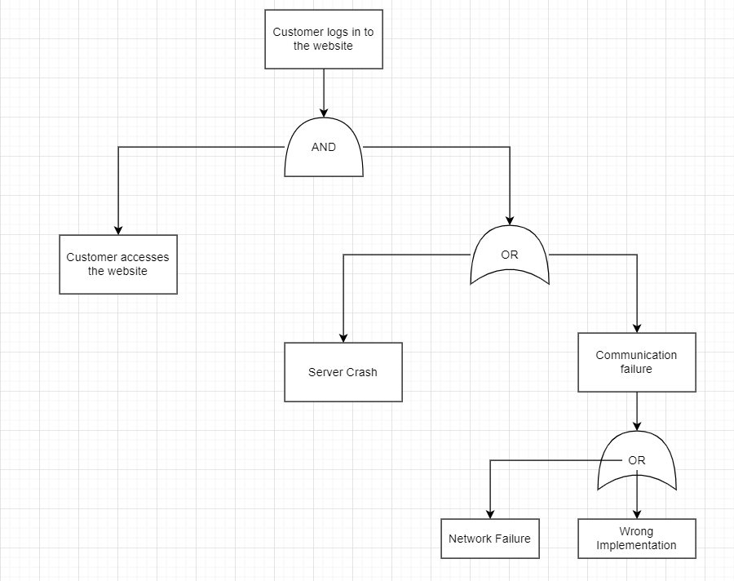

- Quantitative Assessment:

Risk Involved | Rationale | Likelihood | Severity  (1-10) | Risk Exposure  (Likelihood * Severity)
Server Crash | It is very likely that the server crashes because of DDOS attacks or heavy website traffic. | 35% | 8 | 2.8
Reliability and  Availability risks | As the system is not robust enough, it can lead to multiple failures and the recovery rate also won’t be sufficient enough to handle the failures. The maintenance of the website will take long which will affect the availability of the website. | 25% | 7 | 1.75
Security risks | There are very high chances that is security breach and leak of personal information of the users if the encryption is not done as required. | 40% | 9 | 3.6
Cost risks | It is likely that the cost associated with making the software platform independent and cross platform compatible can increase the overall cost of the product | 20% | 6 | 1.2
Performance risks | Slow loading and refreshing rate can greatly affect the overall performance of the product. | 25% | 6 | 1.5

- Risk Control:

